

**Program: ESE 4009**

**INSTRUCTOR:** Prof**.** Mike Aleshams

# Group# 1

|  |  |  |
| --- | --- | --- |
| Student Name | Student ID | Signature* |
| JOYAL RAJU | C0749019 | JR |
| MERLIN MARIAM THANKACHAN | C0748721 | MMT |
| SRUTHY KRISHNAN | C0749122 | SK |

*\*By signing above you attest that you have contributed to this submission and confirm that all work you have contributed to this submission is your own work. Any suspicion of copying or plagiarism in this work will result in an investigation of Academic Misconduct and may result in a “0” on the work, an “F” in the course, or possibly more severe penalties.*

**Project Proposal**

**Project Title:**

**IoT based smart parking system using Beaglebone**

**Description of the latest similar system:**

In the existing system, the PIC microcontroller is the processing unit. This system uses IR sensor, which is placed at entrance to detect the presence of vehicle. When the sensor senses the presence of vehicle its output will become high and that will be fed to the microcontroller and afterwards the microcontroller decrements the number of available spots and gives the output which is shown in the form of blinking LEDs. The green LED lets the first vehicle to enter the lot and once it enters the LED changes to red and stops another vehicle from entering until the first car is parked. IR sensors are also placed at each parking spot. These sensors provide information whether a parking space is occupied or not to the microcontroller. When all the parking lots are full it will be indicated in the LCD. Here, ESP8266 Wifi module is used to transfer data to administrator for tracking the whole activity.

**Limitations of the latest similar system:**

* Processing speed is low, or improvement is possible
* IR sensors are not reliable as it can be affected by sunlight and dark object
* Interfacing ESP8266 with PIC is complicated
* GPS location is not provided for customer
* Multiple entry of vehicle is not possible at a time which makes waiting time more
* Provision for multilevel parking is not present

**Solution 1:**

* **Block Diagram**

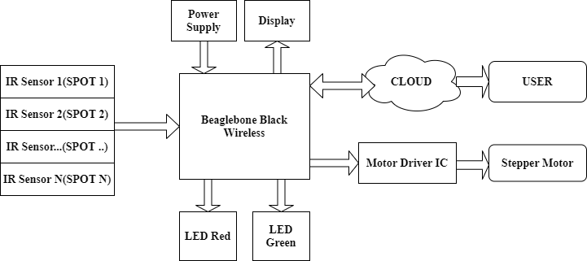

* **Features**
* Beaglebone wireless provide a processing speed up to 1Ghz and easy communication with cloud
* IR Sensors are used to detect the vacant spots.
* LCD will notify the drivers regarding availability of lots.
* LEDs are used to control the entry of vehicles.
* Cloud system is used to update the information timely to the user.
* **Hardware and Software Requirement**
* Beaglebone wireless
* 16*2 LCD
* ULN2003 Driver Board
* Stepper motors
* IR Sensors
* LEDs
* Jumper wires
* Debian for beaglebone
* Embedded c
* Proteus
* ThingSpeak to store and retrieve data
* **References:**

1. **Beaglebone.org (August 2019*). BeagleBone Black Wireless***retrieved from <https://beagleboard.org/black-wireless>
2. **Microcontrollers lab (2017). *parking management system project using pic microcontroller***retrieved from <https://microcontrollerslab.com/parking-management-system-microcontroller/>
3. **ThingSpeak (ND). *ThingSpeak for IOT projects*** retrieved from <https://thingspeak.com/>

**Solution 2:**

* **Block Diagram**

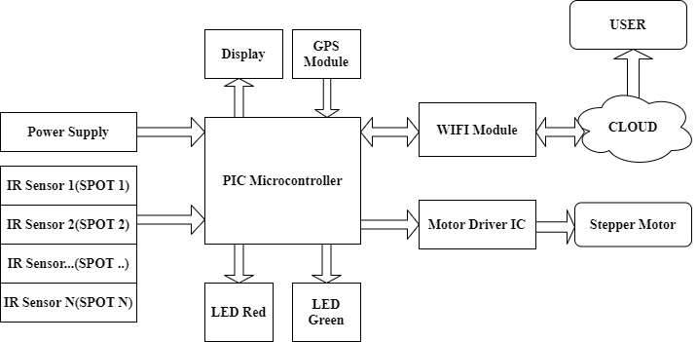

* **Features**
* IR Sensors are used to detect the vacant spots.
* Pic microcontroller is used as processing unit
* ESP8266 is the wifi module used to communicate with cloud.
* GPS module is provided to update the parking location to user
* LCD will notify the drivers regarding availability of lots.
* LEDs are used to control the entry of vehicles.
* Cloud system is used to update the information timely to the user.
* **Hardware and Software Requirement**
* PIC micro controller (PIC16F877A)
* 16*2 LCD
* ULN2003 Driver Board
* Stepper motors
* IR Sensors
* LEDs
* GPS module
* Jumper wires
* MPLAB C
* Embedded C
* Proteus
* **References:**

1. **Microcontrollers lab (2017). *parking management system project using pic microcontroller***retrieved from

<https://microcontrollerslab.com/parking-management-system-microcontroller/>

1. **ThingSpeak (ND). *ThingSpeak for IOT projects*** retrieved from

<https://thingspeak.com/>

1. **Circuit Digest (2018). *Interfacing GPS module with PIC microcontroller*** retrieved from

<https://circuitdigest.com/microcontroller-projects/gps-interfacing-with-pic16f877a>

**Solution 3**

* **Block Diagram**

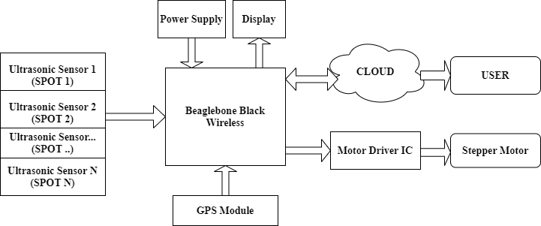

* **Features**
* Beaglebone wireless provide a processing speed up to 1Ghz and easy communication with cloud
* Ultrasonic Sensors are used to detect the vacant spots.
* LCD will notify the drivers regarding availability of lots.
* GPS module is provided to update the parking location to user
* Uses UART serial communication to communicate with GPS module
* Cloud system is used to update the information timely to the user.
* Use preemptive scheduler to reduce the power consumption and unwanted delays in the system.
* **Hardware and Software Requirement**
* Beaglebone wireless
* 16*2 LCD
* ULN2003 Driver Board
* Stepper motors
* Ultrasonic Sensors
* Adafruit Ultimate GPS Breakout board
* Jumper wires
* Debian for beaglebone
* Embedded c
* Proteus
* ThingSpeak to store and retrieve data
* **References:**

1. **Beaglebone.org (August 2019*). BeagleBone Black Wireless***retrieved from <https://beagleboard.org/black-wireless>
2. **Microcontrollers lab (2017). *parking management system project using pic microcontroller***retrieved from <https://microcontrollerslab.com/parking-management-system-microcontroller/>
3. **ThingSpeak (ND). *ThingSpeak for IoT projects*** retrieved from <https://thingspeak.com/>
4. **Paul McWhorter (2015). *Beaglebone black GPS lesson 1: hooking up the adafruit ultimate GPS*** retrieved from

<http://toptechboy.com/beaglebone-black-gps-lesson-1-hooking-up-the-adafruit-ultimate-gps/>